Name: Lokare Mahir Abdul Majeed

Roll No: 23AI34

Batch: 02

Experiment No: 05

AIM: To study and implementation of Support Vector Machine (SVM) algorithm.

RESOURCE REQUIRED:
Google Colab, Dataset, Jupyter Notebook

THEORY:

Support Vector Machine (SVM) is a supervised machine learning algorithm used for both classification and regression tasks. It is primarily used for classification problems. SVM works by finding the optimal hyperplane that best separates data points of different classes in a high-dimensional space.
The main objective of SVM is to find a decision boundary (hyperplane) that maximizes the margin between two classes. The data points closest to the hyperplane are called Support Vectors, and they are the most critical elements in defining the decision boundary.

Types of SVM
Linear SVM: Used when the data is linearly separable, meaning a straight line (or hyperplane in higher dimensions) can clearly separate the classes. It finds the optimal hyperplane with maximum margin between classes.
Non-Linear SVM: Used when data is not linearly separable. It uses kernel functions to transform the data into a higher-dimensional space where a linear separation becomes possible.
SVM for Regression (SVR): Support Vector Regression applies the same principles of SVM to regression tasks. Instead of finding a hyperplane that separates classes, SVR tries to fit the best line within a threshold (epsilon) value.

Key Terminologies in SVM
Hyperplane: A decision boundary that separates different classes. In 2D it is a line, in 3D it is a plane, and in higher dimensions it is called a hyperplane.
Support Vectors: The data points that are closest to the hyperplane and directly influence its position and orientation. Removing these points would change the decision boundary.
Margin: The distance between the hyperplane and the nearest data points (support vectors) from each class. SVM aims to maximize this margin.
Hard Margin SVM: Used when data is perfectly linearly separable with no misclassifications allowed.
Soft Margin SVM: Allows some misclassifications by introducing a slack variable (C parameter) to handle noisy or overlapping data.
Kernel Function: A mathematical function that transforms input data into a higher-dimensional space to make non-linear data linearly separable. Common kernels include:
- Linear Kernel
- Polynomial Kernel
- Radial Basis Function (RBF) / Gaussian Kernel
- Sigmoid Kernel

Assumptions of SVM
Binary Classification (default): Standard SVM is designed for binary classification. Multi-class problems are handled using One-vs-One or One-vs-Rest strategies.
Feature Scaling: SVM is sensitive to the scale of input features. It is assumed that features are normalized or standardized before training.
Optimal Hyperplane Existence: It is assumed that there exists at least one hyperplane that can separate or approximate the separation of classes.
No Irrelevant Features: SVM performs best when irrelevant and redundant features are removed as they can negatively affect the margin computation.

Mathematical Foundation of SVM
For a binary classification problem with classes +1 and -1, the decision function is:
f(x) = w · x + b
Where:
- w = weight vector (normal to the hyperplane)
- x = input feature vector
- b = bias term
The goal is to maximize the margin 2 / ||w||, which is equivalent to minimizing ||w||²/2, subject to the constraint:
yᵢ(w · xᵢ + b) ≥ 1 for all training points i

Kernel Trick
When data is not linearly separable in the original feature space, the kernel trick maps input features into a higher-dimensional space without explicitly computing the transformation:
K(xᵢ, xⱼ) = φ(xᵢ) · φ(xⱼ)
RBF Kernel (most common):
K(xᵢ, xⱼ) = exp(−γ ||xᵢ − xⱼ||²)
Where γ controls the influence of a single training point.

Evaluation Metrics for SVM
Accuracy: Proportion of correctly classified instances. Accuracy = (TP + TN) / (TP + TN + FP + FN)
Precision: Accuracy of positive predictions. Precision = TP / (TP + FP)
Recall (Sensitivity): Proportion of actual positives correctly identified. Recall = TP / (TP + FN)
F1 Score: Harmonic mean of Precision and Recall. F1 Score = 2 × (Precision × Recall) / (Precision + Recall)
Confusion Matrix: A table showing TP, TN, FP, FN counts to evaluate classification performance.
AUC-ROC Curve: Measures the model's ability to distinguish between classes across different thresholds.

IMPLEMENTATION:

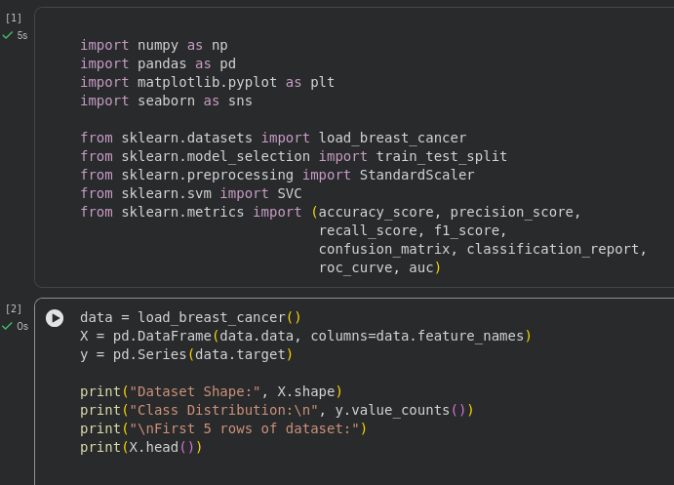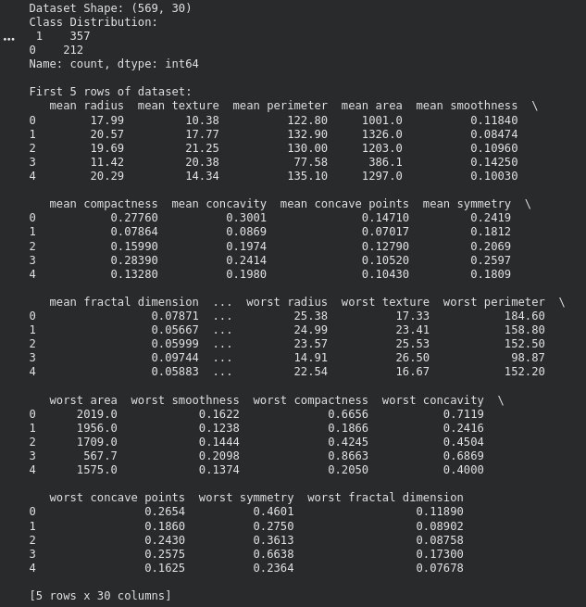

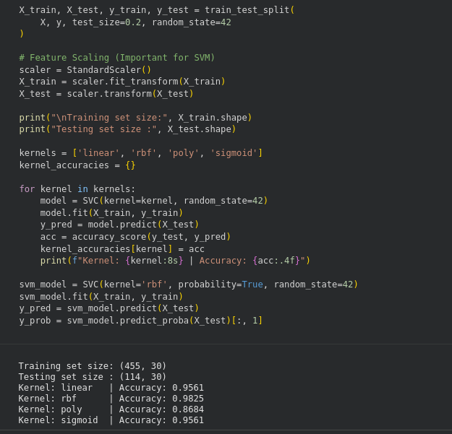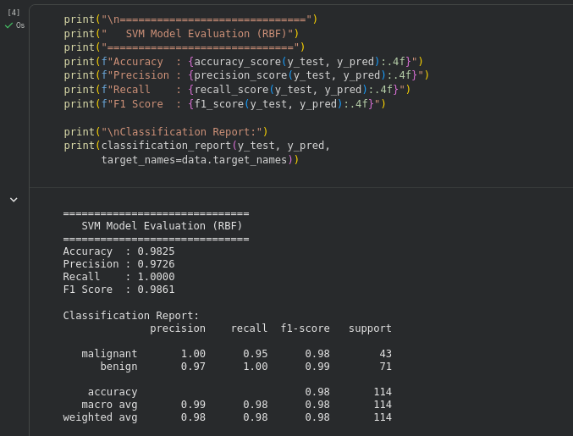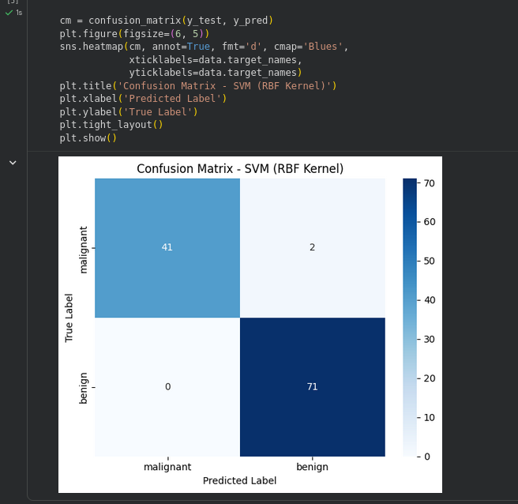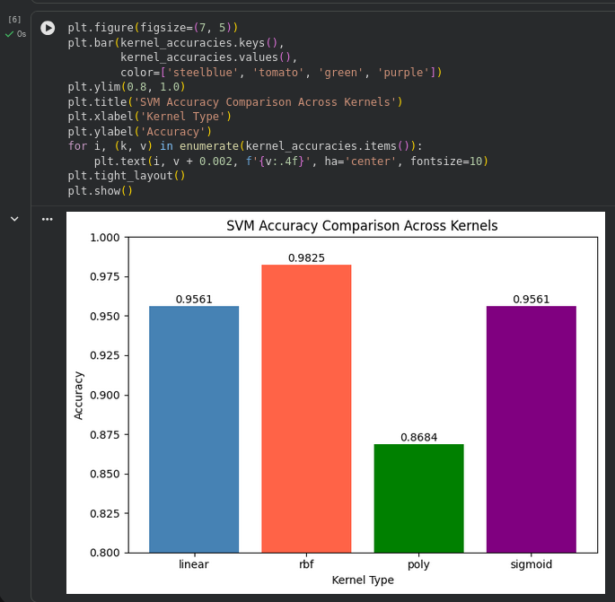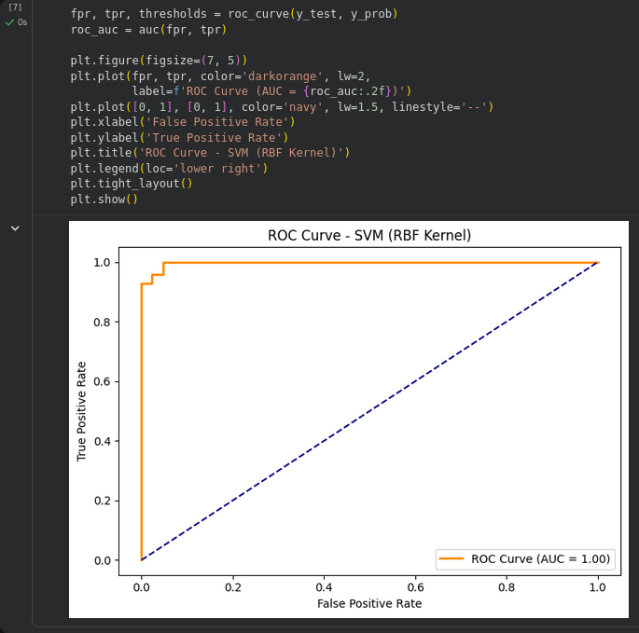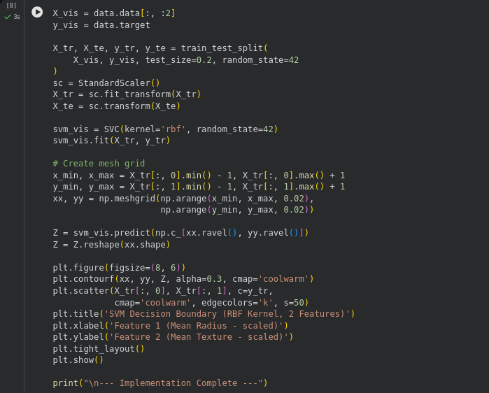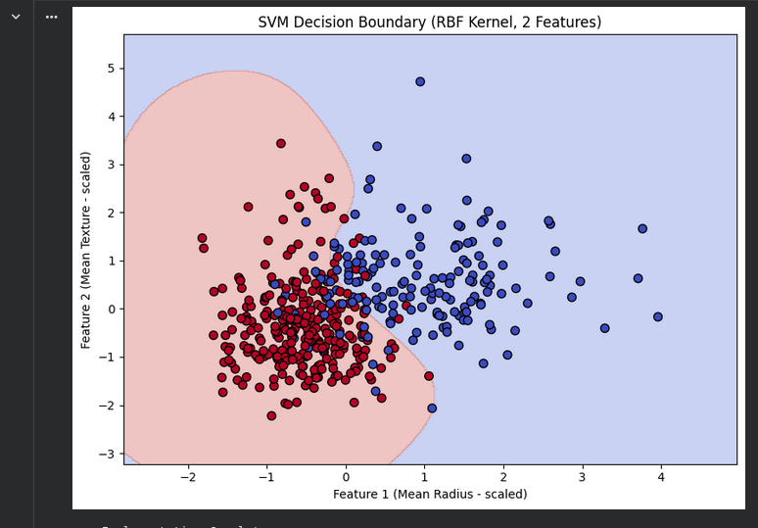

CONCLUSION:
Hence, the implementation of the Support Vector Machine (SVM) algorithm was successfully performed on the Breast Cancer dataset. The model was trained using different kernel functions (Linear, RBF, Polynomial, Sigmoid) and evaluated using metrics such as Accuracy, Precision, Recall, F1 Score, Confusion Matrix, and ROC Curve. The RBF kernel provided the best classification performance among all kernels tested.

